# CS 255 System Design Document Template

This template lays out all the different sections that you need to complete for Project Two. Each section has guidance to prompt your thinking. You will need to continually reference the interview transcript as you work to make sure that you are addressing your client’s needs. There is no required length for the final document. Instead the goal is to complete each section based on what your client’s needs are. Remove this note when you are finished, and replace all bracketed text with the relevant information.

## UML Diagrams

### UML Use Case Diagram

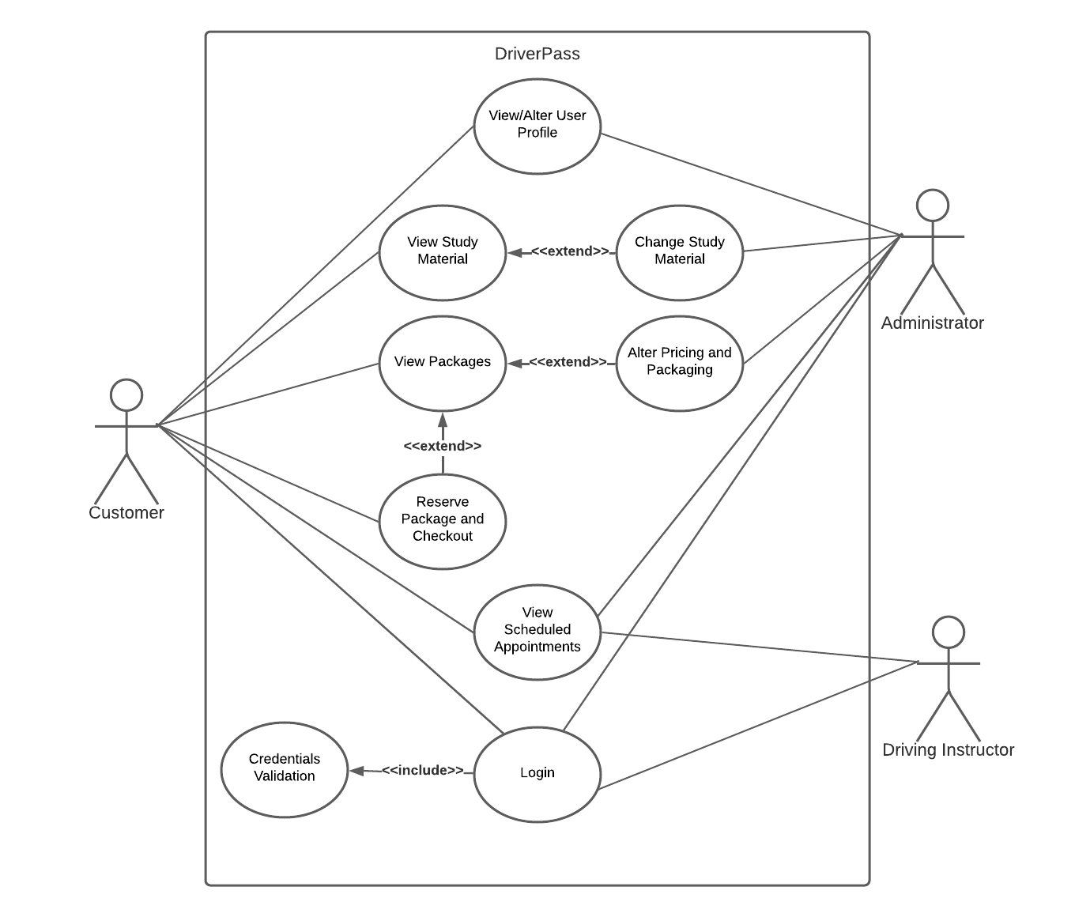

### UML Activity Diagrams

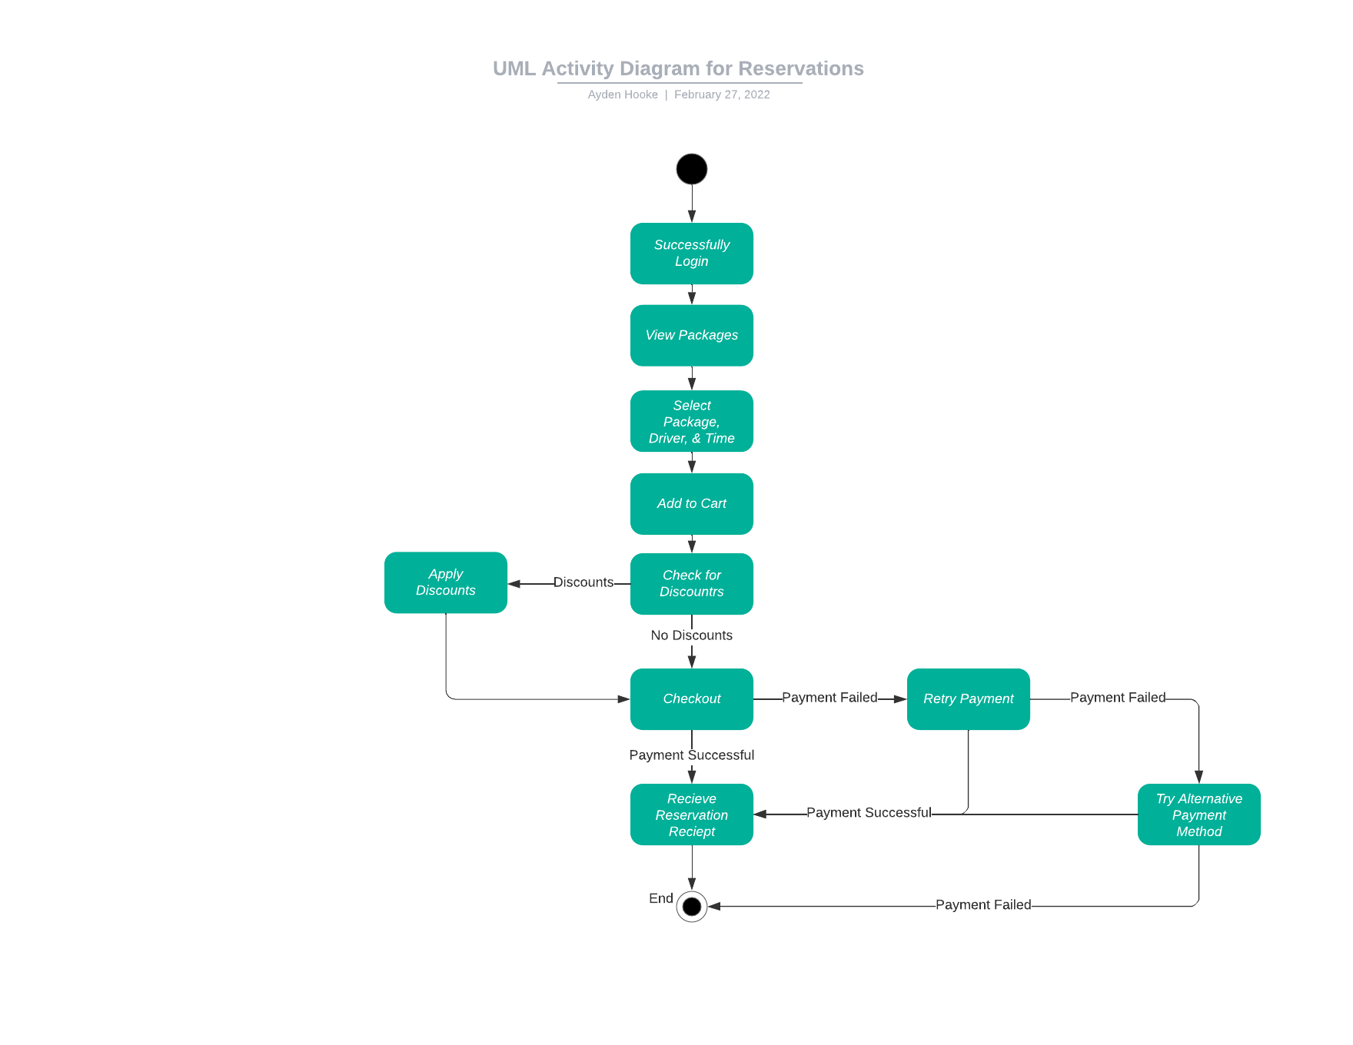

### UML Sequence Diagram

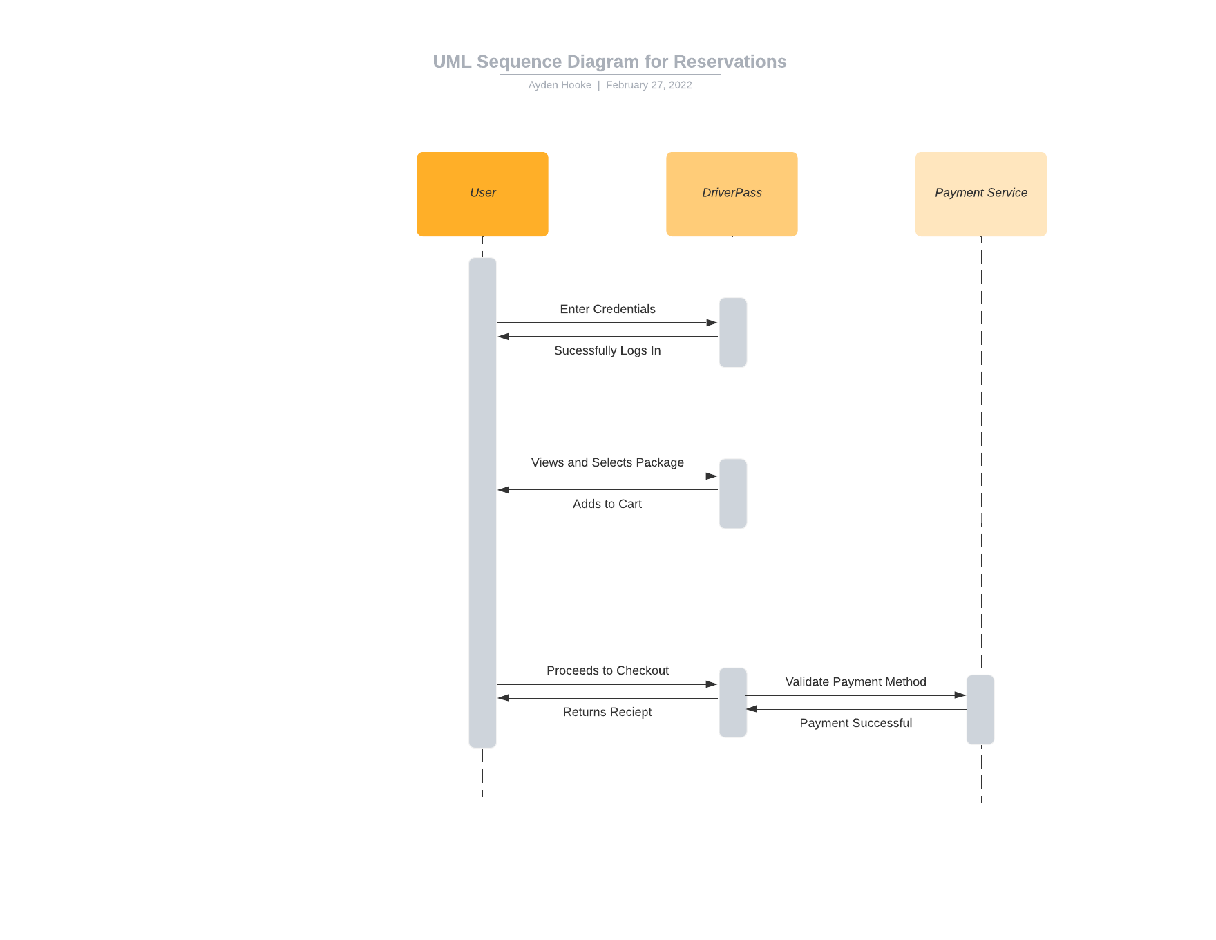

### UML Class Diagram

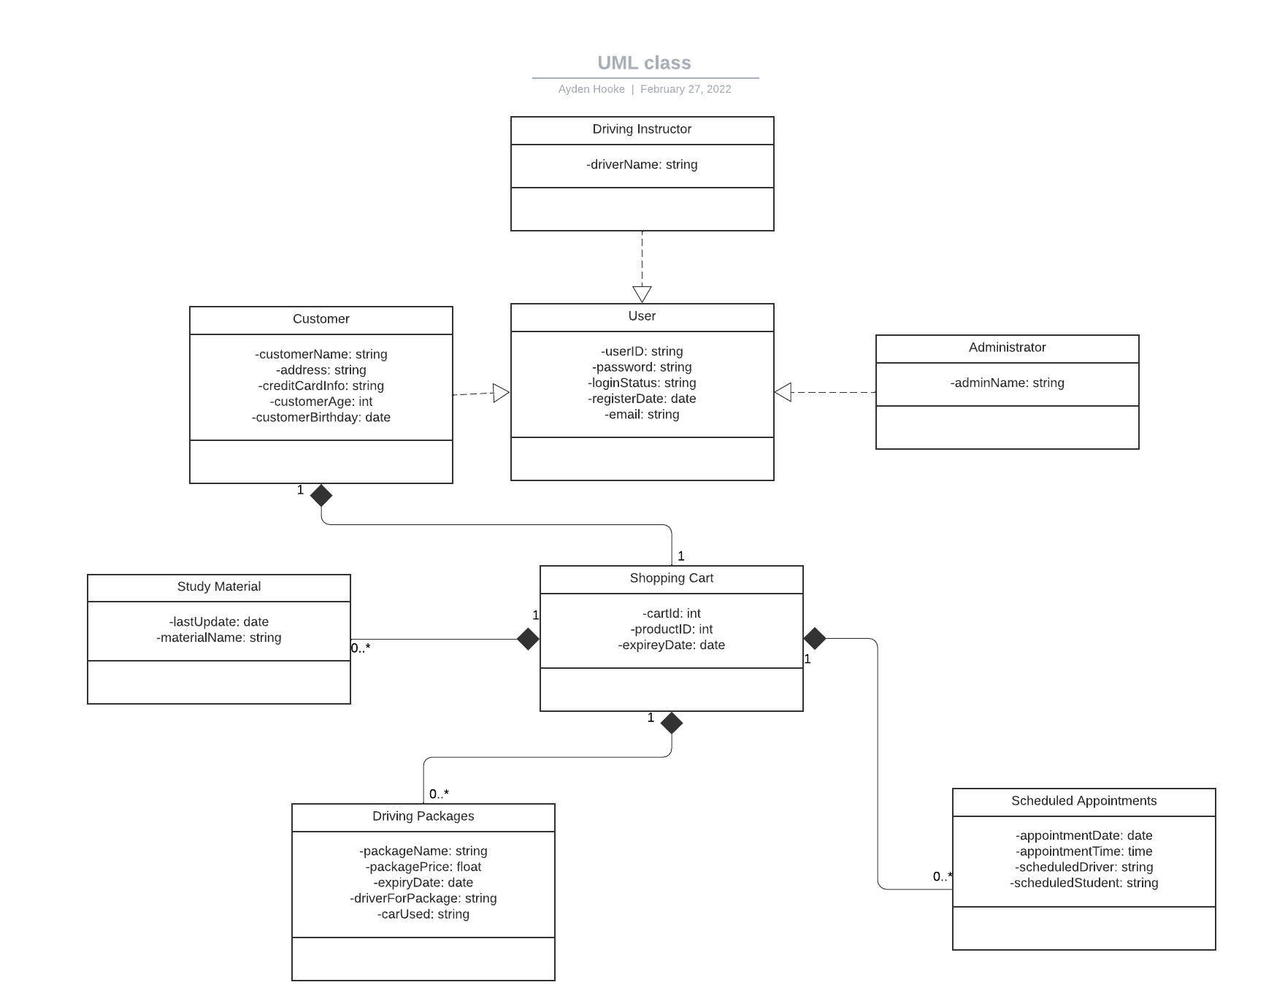

## Technical Requirements

One thing that DriverPass would most certainly need is a server that would be capable of running a website on the cloud so that all of their employees and their customers can access what they need to access on their website. They would also need to be able to have payment services be able to communicate with their servers. They would also have to deploy cryptographic measures to ensure the security of their clients’ data.